KPSI -

Functionality
Activity Types in the SAP system offer a method to reallocate costs from a cost center to a receiver. Using activity types you reallocate costs based on the unit of activity you have defined, such as maintenance hours, labor hours or production hours.

You plan the quantities as follows:
- You plan the output of activities on the sender; this can only be a cost center
- You plan the consumption of activities on the receiver cost objects: cost centers, internal orders, PS network or WBS, product cost collectors etc.
A special case here is when the consumption of activity types is not entered manually but is transferred from S&OP/ MRP Long term planning. Based on the planned quantity of manufactured product, the system calculates the quantity of activities required for the production and transfers these quantities to CO.

In Plan reconciliation you reconcile the output against the consumption quantity.
When running the transaction, a report will be presented that compares both quantities. When you post the reconciliation, the consumption quantities will overwrite the output quantities that you have entered.
So be sure that you are fine with the consumption quantities when you post. You may also decide to stick with the quantities you have entered for the output.

Scenario
Proceed with the plan reconciliation of activity types for cost center group 1201 Production as a part of the planning process for the year 2003.

Requirements
- You have planned the activity output on the sender cost center and the activity input on the receiver cost objects
- You have transferred the scheduled activities from Production Planning into CO.

Menu Path | Accounting → Controlling → Cost Center Accounting → Planning → Planning Aids → KPSI - Plan Reconciliation
Transaction Code | KPSI

1. Double Click on KPSI - Plan Reconciliation

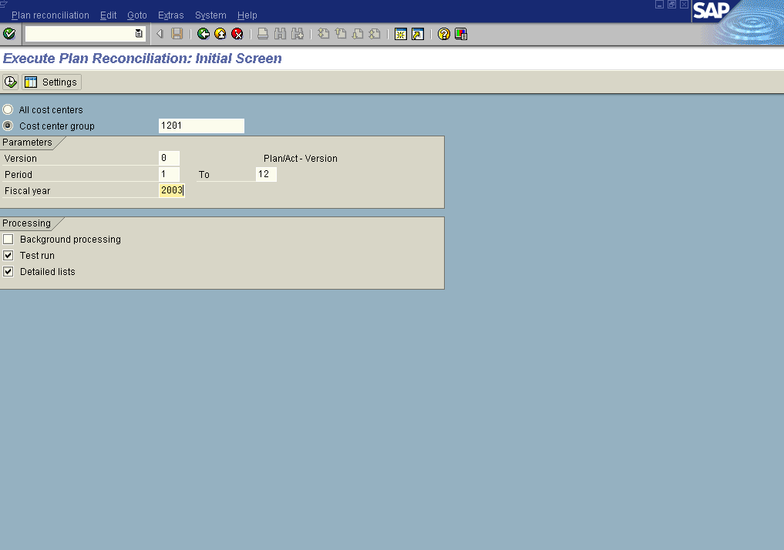

2. Click the <radio button> Cost center group .
3. Update the following fields:
Field Name | Field Description | Values
Version | Controlling area related collection of year-dependent indicators for planning data. | Example: 0
Cost center group | Code identifying a grouping, for plan reconciliation, of cost centers with similar characteristics | Example: 1201
Period | Number identifying a beginning fiscal month | Example: 1
To | Number identifying a ending fiscal month | Example: 12
Fiscal Year | The fiscal year can be the same as the calendar year, but does not have to be. | Example: 2003

Note: When you choose Settings you can limit the number of iterations and the scope of the plan reconciliation.

Note:
Always run a test run first

4. Make sure checkbox Test run is checked.

5. Click on the Execute

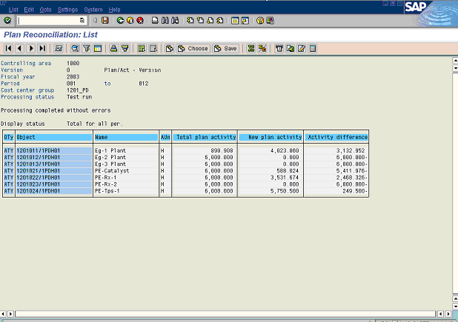

6. Select the row and click Period values Button .

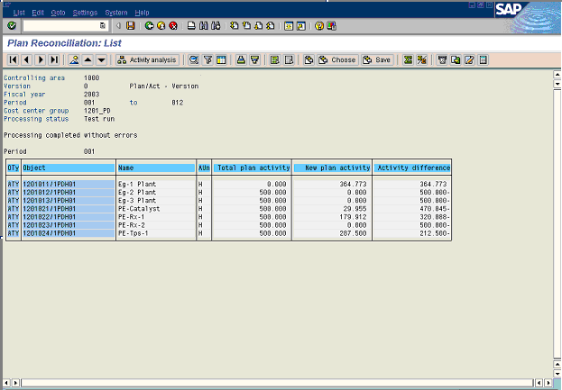

This list is used to display the reconciliation of planned activity quantities per period
Click the Next period button to go to the plan reconciliation list screen of the next period from specified interval of periods.

7. Select the row and click Activity analysis Button .

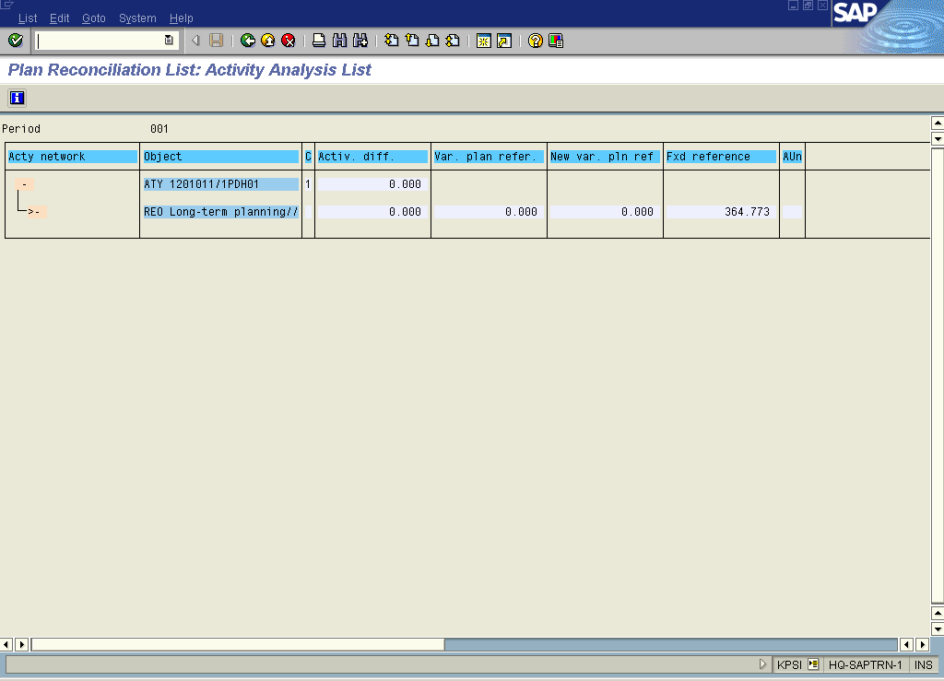

Note: This is used to display the further activity flow in the SAP System going out from a selected activity type in a cost center. In this way, the activity flow can be followed through several cost centers.

8. Click the Back button.

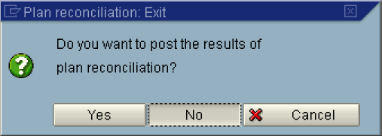

Note:
-If you are fine with the results of the test run, you post the Plan Reconciliation here.
-If you are not fine with the results, you do not post.
The result of the posting is that the values of the column “New planned activity” will overwrite the values of the column “Planned activity”.

9. Click the Yes or No button

E

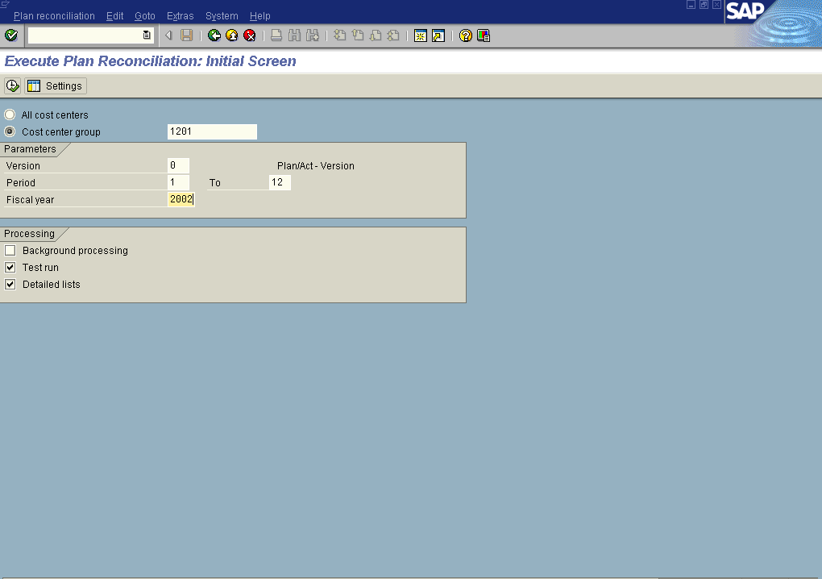

10. Click the Back button to go back to the SAP Easy Access screen.

